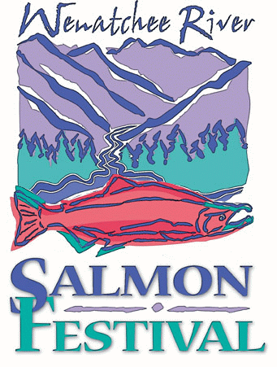

June 2014

Hello Potential Festival Exhibitor,

We are pleased to share exhibitor information with you for the award winning Wenatchee River Salmon Festival on September 18, 19, 20, 2014. The Salmon Fest, located at the Leavenworth National Fish Hatchery, promises to be an exciting educational family-style event. The Festival focuses on natural resource education, outdoor recreation and shares the cultural significance of the salmon to people of the Northwest. This event draws 8,000 - 10,000 people per year.

What an ideal time for you to share your mission to thousands by having an interactive educational exhibit in our exhibit tent area. We hope you can join us.

We will be signing exhibitors up on a first come, first served basis. Please complete and mail the attached application. Again this year, the exhibitors will be located by the stage on the grassy lawn at Hatchery Park which is an excellent central location. You will find more information about this year’s festival on the attached information sheet. We can be reached at (509)548-6662 and will be happy to answer any of your questions concerning this year’s event and provide any information you may need. We sure hope you’ll come share your story in this fun filled event!

Sincerely,

Sheila Bergren
Susan Peterson
Festival Coordinators

ADDITIONAL INFORMATION
Guidelines:
- Exhibits should stress the Festival’s objectives of natural resource education and/or outdoor recreation. We challenge you to make them as interactive and educational as possible.

- The festival organization is dedicated to providing quality educational exhibits in a non-political, non-commercial format. The Salmon Festival Board will review all exhibitor applications and make a determination of appropriateness.

- The Festival provides two Kids Days on September 18 & 19 when 4th and 5th grade classes visit the Festival. Exhibitors may exhibit for Kids Days and/or Family Day on September 20. Please specify the days you are willing to exhibit on the application form.

- There are a limited number of electrical outlets available. Outlets will be available on request. All exhibitors must provide their own tables.

- This is a non-commercial exhibitor event so no products can be sold across the counter. Business cards, catalogs and informational handouts are acceptable.

- Private and Forest Service camping areas are available in the Leavenworth area. A variety of lodging is also available in Leavenworth. You can call the Leavenworth Chamber of Commerce at (509) 548-5807 for more information. Make reservations early!

EXHIBIT SCHEDULE:
Set up Times
Wednesday September 17 12 noon to 5 pm
Thursday September 18 6am to 8:30 am
Friday September 19 3:30pm to dark
Saturday September 20 6am to 9:00 am
Exhibit Hours
Thursday September 18 9am to 3pm
Friday September 19 9am to 3pm
Saturday September 20 10am to 5pm

Exhibit Teardown: Saturday after 5pm

EXHIBITOR REGISTRATION

Mail to: Sheila Bergren
Leavenworth National Fish Hatchery
12790 Fish Hatchery Road
Leavenworth WA 98826

Questions: (509)548-6662

Name

Name Agency/Group

Mission and educational goals of your organization______________________________________________________________________________________________________________________________________________________________________________________________________________________________________

Address

Phone No

What is your major theme?

Days you are willing to exhibit (please check)

September 18 - 20 (All days)
September 18 - 19 (Kids days)
September 20 (Family day) _____

Do you need an electrical outlet? Yes No

Do you need more than a 10' X 10' space? Yes No

Do you have any other needs or questions? If so, please specify below:

